# Android Studio

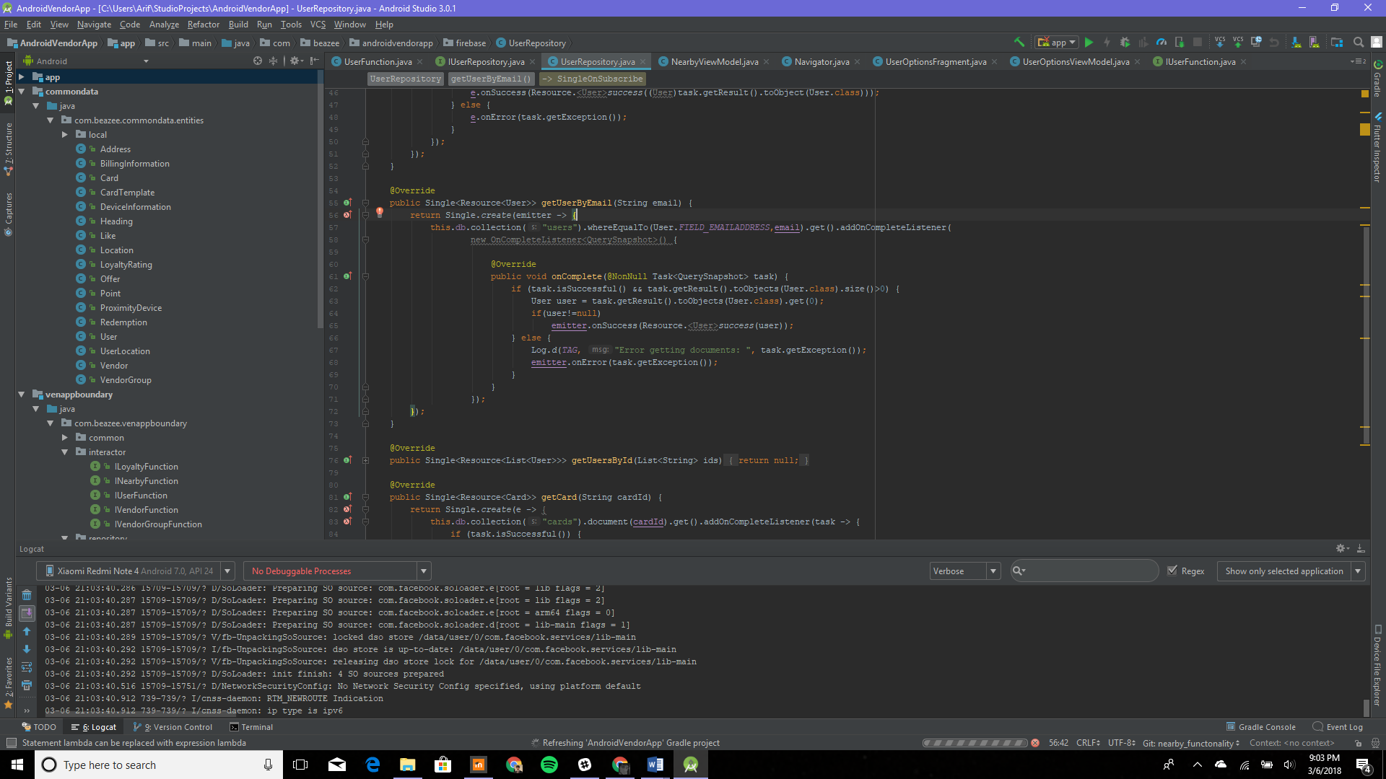

## Consistency

Consistency can be found in the following areas:

* Every file is opened in a tab.
* The code highlighting is also a part or consistency.
* Error highlighting is also consistent. All the syntax or logical errors are underlined with twisted red line.
* Just like other program it’s menu options are divided.

## Affordance

Affordance refers to whether the user interface is clear and is easy to be understood by the user. Android studio is complex software, so it’s difficult to achieve affordance to fullest. Also, it is used by technical persons, so it does not matter a lot. One has to learn how to use it.

## Visibility

Android studio is good in this part. All the components are easily visible. If the component is not visible its tab icon is visible and the user understands.

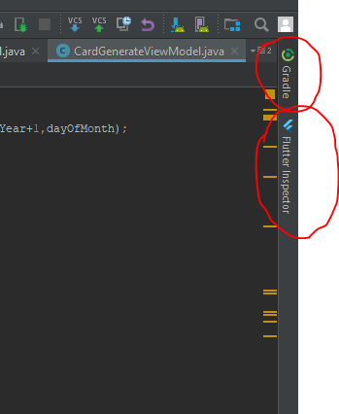

## Feedback

Feedback means that the user should be aware of what is happening instantly after his/her command. Android studio is good at it. It gives feedback to user whenever a long task is running and expects the user to wait.

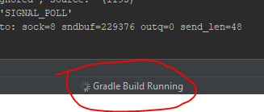

## Constraints

Constraints tell the user whenever a particular feature is disabled or unable to work. It is very common in android. Whenever the configuration of the project is wrong you cannot build the project and run it. The button is not clickable.

## Mapping

Correct mapping is important in IDEs. In android studio all the icons are used correctly.

For example:  The bug with play sign icon suggests that run the project in debug mode.s